Solution: Style a component

Overview
In this reading, you will review the solution code for the exercise.
The image below demonstrates the expected output of the exercise. Follow each step below to explore the solution code.
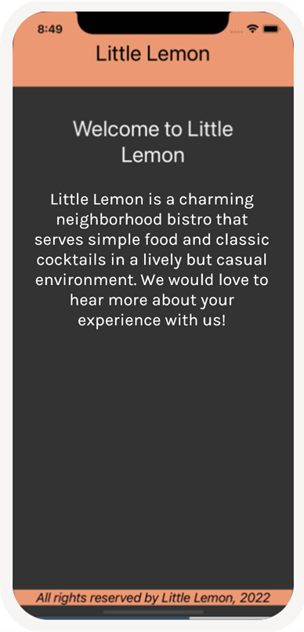

Procedure
Here is a breakdown of the individual steps.

Step 1: Update Styles of Components to match Scenario
In this step, you will update the styles in each component to match the screenshots provided. The components now have different background colors, font style and text color. Update the necessary styles to match the recommended output.

LittleLemonFooter.js
import * as React from 'react';
import { View, Text } from 'react-native';
export default function LittleLemonFooter() {
return (
<View
style={{
backgroundColor: '#EE9972',
marginBottom: 20,
}}>
<Text
style={{
fontSize: 18,
color: 'black',
textAlign: 'center',
fontStyle: 'italic',
}}>
All rights reserved by Little Lemon, 2022{' '}
</Text>
</View>
);
}

LittleLemonHeader.js
import * as React from 'react';
import { View, Text } from 'react-native';

export default function LittleLemonHeader() {
return (
<View style={{ backgroundColor: '#EE9972' }}>
<Text style={{ padding: 40, fontSize: 30, color: 'black', textAlign: "center" }}>
Little Lemon
</Text>
</View>
);
}

WelcomeScreen.js
import * as React from 'react';
import { ScrollView, Text } from 'react-native';

export default function WelcomeScreen() {
return (
<ScrollView indicatorStyle="white" style={{ flex: 1 }}>
<Text
style={{
padding: 40,
fontSize: 30,
color: '#EDEFEE',
textAlign: 'center',
}}>
Welcome to Little Lemon
</Text>
<Text
style={{
fontSize: 24,
padding: 20,
marginVertical: 8,
color: '#EDEFEE',
textAlign: 'center',
}}>
Little Lemon is a charming neighborhood bistro that serves simple food
and classic cocktails in a lively but casual environment. We would love
to hear more about your experience with us!
</Text>
</ScrollView>
);
}

App.js
import * as React from 'react';
import { View, Text } from 'react-native';

import LittleLemonHeader from './components/LittleLemonHeader';
import LittleLemonFooter from './components/LittleLemonFooter';
import WelcomeScreen from "./WelcomeScreen";

export default function App() {
return (
<>
<View
style={{
flex: 1,
backgroundColor: '#333333',
}}>
<LittleLemonHeader />
<WelcomeScreen />
</View>
<View style={{ backgroundColor: '#333333' }}>
<LittleLemonFooter />
</View>
</>
);
}

Step 2: Extract All Styles to StyleSheet API
In this step, ensure to extract the styles away from the component’s render and instead add them to the StyleSheet const. This way the styles are given meaningful names and do not mix with the JSX code within the component.

Refactor WelcomeScreen.js
import * as React from 'react';
import { ScrollView, Text, StyleSheet } from 'react-native';

export default function WelcomeScreen() {
return (
<ScrollView indicatorStyle="white" style={styles.container}>
<Text style={styles.headerText}>Welcome to Little Lemon</Text>
<Text style={styles.regularText}>
Little Lemon is a charming neighborhood bistro that serves simple food
and classic cocktails in a lively but casual environment. We would love
to hear more about your experience with us!
</Text>
</ScrollView>
);
}

const styles = StyleSheet.create({
container: {
flex: 1,
},
headerText: {
padding: 40,
fontSize: 30,
color: '#EDEFEE',
textAlign: 'center',
},
regularText: {
fontSize: 24,
padding: 20,
marginVertical: 8,
color: '#EDEFEE',
textAlign: 'center',
},
});

Refactor LittleLemonHeader.js
import * as React from 'react';
import { View, Text, StyleSheet } from 'react-native';

export default function LittleLemonHeader() {
return (
<View style={styles.container}>
<Text style={styles.headerText}>Little Lemon</Text>
</View>
);
}

const styles = StyleSheet.create({
container: {
backgroundColor: '#EE9972',
},
headerText: {
padding: 40,
fontSize: 30,
color: 'black',
textAlign: 'center',
},
});

Refactor LittleLemonFooter.js
import * as React from 'react';
import { View, Text, StyleSheet } from 'react-native';

export default function LittleLemonFooter() {
return (
<View style={styles.container}>
<Text style={styles.footerText}>
All rights reserved by Little Lemon, 2022{' '}
</Text>
</View>
);
}

const styles = StyleSheet.create({
container: {
backgroundColor: '#EE9972',
marginBottom: 20,
},
footerText: {
fontSize: 18,
color: 'black',
textAlign: 'center',
fontStyle: 'italic',
},
});

